28 June 2021

Dear Parent Carers,

The Wirral Special Educational Needs and Disability (SEND) Strategic Board has been reflecting on local area collaboration with Parent Carers and children and young people with SEND. This reflection has been timed with a review of board structure and implementation of a series of focused sub groups to bring about the changes required locally.

The Board is looking for parent carers who are able to represent the perspectives of a wide population of other parent carers at the Strategic Board and within a range of the initial sub groups. Where parent carers are interested in undertaking one or some of the following roles we would welcome an expression of interest to Sally Tittle, SEND Participation Manager, via e mail [sallytittle@wirral.gov.uk](mailto:sallytittle@wirral.gov.uk) by 9 July 2021.

There is also an opportunity to discuss the listed roles in more detail with Richard Crockford or James Backhouse as the co-chairs of the Board.

* Attendance at the Strategic Board representing the views of Parent Carers with early years children.
* Attendance at the Strategic Board representing the views of Parent Carers with school age children.
* Attendance at the Strategic Board representing the views of Parent Carers with young people transitioning to adulthood.
* Attendance at the Transitional sub-group that will have a key role in reviewing current arrangements and support for transitional periods included children’s to adult’s health and social services and through the range of educational key stages
* Attendance at the Co-Production sub-group that will consider how we can ensure true coproduction in service design
* Attendance at the Early Identification and Intervention sub-group to explore the existing processes to identify children and young people with SEND needs as early as possible to offer timely support

We would greatly appreciate it if expressions of interest submitted could detail the parent carer population that you would represent and the route that you would utilise to gain a wide perspective of other parent carers.

Thank you for considering these role and we look forward to further collaboration.

Regards,  
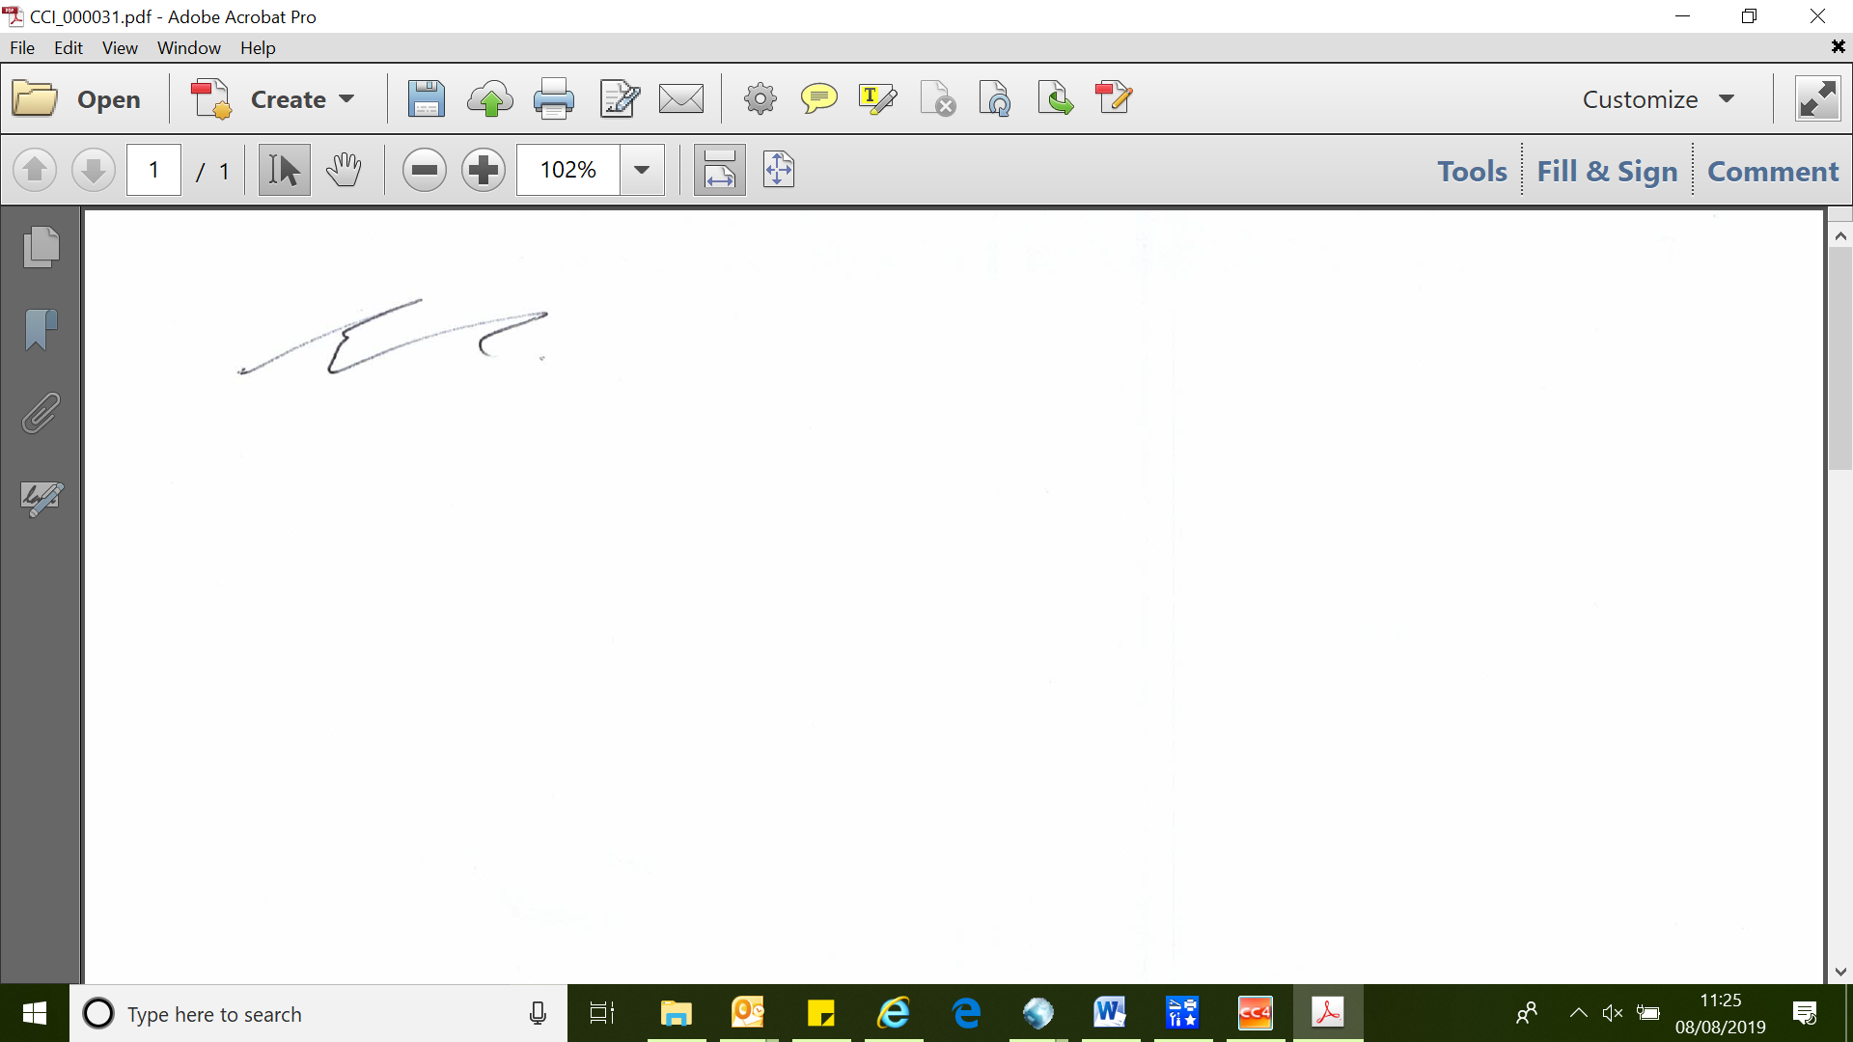 

Richard Crockford James Backhouse

[richard.crockford@nhs.net](mailto:richard.crockford@nhs.net) [jamesbackhouse@wirral.gov.uk](mailto:jamesbackhouse@wirral.gov.uk)