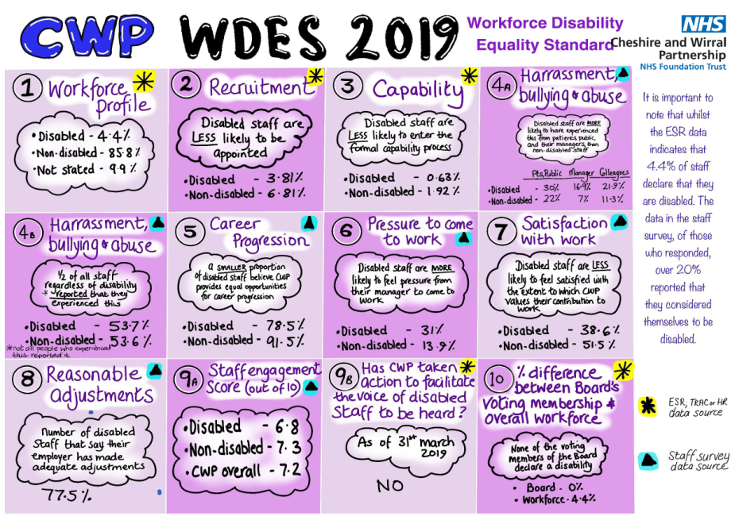

Workforce Disability Equality Standard 2018-19

The NHS Workforce Disability Equality Standard Indicators

Workforce Indicators
For each of these four workforce indicators, compare the data for Non-Disabled and Disabled staff
- Percentage of staff in AfC pay bands or medical and dental subgroups and very senior managers (including Executive Board members) compared with the percentage of staff in the overall workforce.
Note: Definitions for these categories are based on Electronic Staff Record occupation codes with the exception of medical and dental staff, which are based upon grade codes
- Relative likelihood of Disabled staff being appointed from shortlisting compared to Non-Disabled staff across all posts
- Relative likelihood of Disabled staff compared to Don-Disabled staff entering the formal capability process, as measured by entry into the formal capability procedure.
Note: This indicator will be based on data from a two year rolling average of the current year and the previous year

National NHS Staff Survey indicators (or equivalent)
For each of the staff survey indicators, compare the outcomes of the responses for Non-Disabled and Disabled staff.

  - Percentage of staff experiencing harassment, bullying or abuse from patients, relatives or the public in last 12 months from:
    - Patients/service users, their relatives or other members of the public
    - Managers
    - Other colleagues
  - Percentage of Disabled staff compared to Non-Disabled staff saying that the last time they experienced harassment, bullying or abuse at work, they or a colleague reported it.
- Percentage of Disabled staff compared to Non-Disabled staff believing that the Trust provides equal opportunities for career progression or promotion.
- Percentage of Disabled staff compared to Non-Disabled staff saying that they have felt pressure from their manager to come to work, despite not feeling well enough to perform their duties.
- Percentage of Disabled staff compared to Non-Disabled staff saying that they are satisfied with the extent to which their organisation values their work.
- Percentage of Disabled staff saying that their employer has made adequate adjustment(s) to enable them to carry out their work.

The staff engagement score for Disabled staff, compared to non-disabled staff and the overall engagement score for the organisation.

Has your Trust taken action to facilitate the voices of Disabled staff in your organisation to be heard? As at 31 March 2019 – No. (to note, we are taking action since the reporting period)
If yes, please provide at least one practical example of current action being taken in the relevant section of your WDES annual report. If no, please include what action is planned to address this gap in your WDES annual report. Examples are listed in the WDES technical guidance

Board representation indicator
For this indicator, compare the difference for Non-Disabled and Disabled staff
- Percentage difference between the organisation’s Board voting membership and its organisation’s overall workforce, disaggregated:
Note: Only voting members of the Board should be included when considering this indicator

Indicator 1 - Percentage of staff in each of the AfC Bands 1-9 and VSM (including executive Board members) compared with the percentage of staff in the overall workforce
Clinical or non-clinical |  | Disabled | Non-Disabled | Not stated
Clinical | Band 1 | 0.0% | 0.0% | 0.0%
 | Band 2 | 0.0% | 91.7% | 8.3%
 | Band 3 | 4.8% | 82.7% | 12.5%
 | Band 4 | 2.2% | 90.0% | 7.8%
 | Band 5 | 4.1% | 90.2% | 5.7%
 | Band 6 | 3.5% | 87.7% | 8.7%
 | Band 7 | 4.5% | 89.4% | 6.1%
 | Band 8a | 2.9% | 89.2% | 7.8%
 | Band 8b | 0.0% | 91.7% | 8.3%
 | Band 8c | 0.0% | 70.0% | 30.0%
 | Band 8d | 0.0% | 100.0% | 0.0%
 | Other / Local Pay | 4.6% | 26.7% | 68.7%
 | VSM | 0.0% | 100.0% | 0.0%
 | Medical and Dental | 3.7% | 87.9% | 8.4%
 | of which consultants | 3.6% | 86.9% | 9.5%
 | of which Senior medical manager | 0.0% | 100.0% | 0.0%
 | of which non cons career grades | 6.3% | 93.8% | 0.0%
 | of which trainee grades | 0.0% | 100.0% | 0.0%
 | of which others | 0.0% | 100.0% | 0.0%
Clinical Total |  | 3.8% | 84.7% | 11.5%
Non-clinical | Band 1 | 9.7% | 83.9% | 6.5%
 | Band 2 | 6.2% | 90.0% | 3.8%
 | Band 3 | 4.7% | 90.0% | 5.4%
 | Band 4 | 5.8% | 90.5% | 3.6%
 | Band 5 | 6.8% | 89.8% | 3.4%
 | Band 6 | 2.9% | 92.8% | 4.3%
 | Band 7 | 2.4% | 92.9% | 4.8%
 | Band 8a | 0.0% | 87.0% | 13.0%
 | Band 8b | 3.3% | 86.7% | 10.0%
 | Band 8c | 12.5% | 87.5% | 0.0%
 | Band 8d | 0.0% | 0.0% | 0.0%
 | Other / Local Pay | 11.1% | 0.0% | 88.9%
 | VSM | 8.7% | 91.3% | 0.0%
Non clinical Total |  | 5.6% | 88.8% | 5.6%
Grand Total |  | 4.4% | 85.8% | 9.9%

Indicator 2 - Relative likelihood of staff being appointed from shortlisting across all posts

Current Year 2018-19
 | Shortlisted | Appointed | Relative Likelihood of Shortlisted/Appointed
Disabled | 341 | 13 | 3.81%
Non-Disabled | 4520 | 308 | 6.81%
Not Stated | 153 | 43 | 28.10%
I do not wish to disclose | 98 | 3 | 3.06%
Relative Likelihood of Non-Disabled staff being appointed from shortlisting compared to Disabled |  |  | 1.79 Times more likely

The relative likelihood indicates that Disabled staff are LESS likely to appointed when compared to Non-Disabled staff

Indicator 3 - Relative likelihood of Disabled staff compared to non-disabled staff entering the formal capability process, as measured by entry into the formal capability procedure.
Note: This indicator is based on data from a two year rolling average of the current year and the previous year
Current Year 2017-18 and 2018-19
Average over 2 years | Entering Formal Capability Process | Trust Headcount | Relative Likelihood of staff entering the capability Process
Non-Disabled | 59 | 3071 | 1.92%
Disabled | 1 | 158 | 0.63%
Not Stated | 1 | 16 | 6.25%
Relative Likelihood of Disabled staff entering the formal Disciplinary process compared to Non-Disabled staff. |  |  | 0.33

The relative likelihood indicates that Disabled staff are LESS likely to enter the formal capability process when compared to Non-Disabled staff

Percentage of Staff Survey respondents who stated they have a disability
Category | 2018 Survey | 2017 Survey | 2016 Survey
Non-Disabled | 79% | 77% | 82%
Disabled | 21% | 23% | 18%

A fifth (21%) of all staff completing their staff survey in 2018 identified they have a disability. The current workforce on ESR only 4.43% have a disability stated against their staff file.

Indicator 4a - Percentage of Disabled staff compared to non-disabled staff experiencing harassment, bullying or abuse from
Category | Question | 2018 Survey | 2017 Survey | 2016 Survey
Non-Disabled | Patients/service users, relatives or public | 22.6% | 22% | 24%
 | Managers | 7.0% | 8.0% | Not available
 | Other colleagues | 11.3% | 9.0% | 15%
Disabled | Patients/service users, relatives or public | 30.8% | 33% | 27%
 | Managers | 16.9% | 15% | Not available
 | Other colleagues | 21.9% | 20% | 21%

The results from the latest staff survey in 2018 indicate that Disable staff are MORE likely to have experienced harassment, bullying or abuse from Patients/Service users, relatives or other members of the public and from their managers than non-disabled staff.

Indicator 4b - Percentage of Disabled staff compared to non-disabled staff saying that the last time they experienced harassment, bullying or abuse at work, they or a colleague reported it.

Category | 2018 Survey | 2017 Survey | 2016 Survey
Non-Disabled | 53.6% | 61% | 60%
Disabled | 53.7% | 58% | 56%

The results from the latest staff survey indicates that approximately half of all staff regardless of disability reported an experience of harassment, bullying or abuse at work.

Indicator 5 - Percentage of Disabled staff compared to non-disabled staff believing that the

Trust provides equal opportunities for career progression or promotion.
Category | 2018 Survey | 2017 Survey | 2016 Survey
Non-Disabled | 91.5% | 91% | 92%
Disabled | 78.5% | 84% | 88%

The results from the latest staff survey indicates that a larger proportion of disabled staff believe the trust provides equal opportunities for career progression than non-disabled staff.

Indicator 6 - Percentage of Disabled staff compared to non-disabled staff saying that they have felt pressure from their manager to come to work, despite not feeling well enough to perform their duties
Category | 2018 Survey | 2017 Survey | 2016 Survey
Non-Disabled | 13.9% | 16% | 49%
Disabled | 31.0% | 24% | 64%

The results from the latest staff survey indicates that disabled staff are MORE likely to feel pressure from their manager to come to work than non-disabled staff. This was also the case for 2017 and 2016

Indicator 7 - Percentage of Disabled staff compared to non-disabled staff saying that they are satisfied with the extent to which their organisation values their work.
Category | 2018 Survey | 2017 Survey | 2016 Survey
Non-Disabled | 51.5% | 50% | Not available
Disabled | 38.6% | 39% | Not available

The results from the latest staff survey indicates that disabled staff are LESS likely to feel satisfied with the extent to which CWP values their work than non-disabled staff. Results of the 2017 staff also indicate that disabled staff are less likely to feel satisfied with the extent to which CWP values their work than non-disabled staff.

Indicator 8 - Percentage of Disabled staff saying that their employer has made adequate adjustment(s) to enable them to carry out their work.
Category | 2018 Survey | 2017 Survey | 2016 Survey
Disabled | 77.5% | 79% | 84%

The percentage of disabled staff saying that the trust has made adequate adjustment(s) to enable them to carry out their work has declined year-on-year. Almost a quarter of disabled staff feeling that trust hasn’t made adequate adjustments.

Indicator 9a - The staff engagement score for Disabled staff, compared to non-disabled staff and the overall engagement score for the organisation. (Out of 10)
Category | 2018 Survey
Non-Disabled | 7.3
Disabled | 6.8
Overall Trust | 7.2

Indicator 9b - Has your Trust taken action to facilitate the voices of Disabled staff in your organisation to be heard? (Yes) or (No)
If yes, please provide at least one practical example of current action being taken in the relevant section of your WDES annual report. If no, please include what action is planned to address this gap in your WDES annual report. Examples are listed in the WDES technical guidance

Indicator 10 - Percentage difference between the organisations’ Board voting membership and its overall workforce
Category | Board Member |  | Overall Workforce
Non-Disabled | 13 | 100.00% | 3071 | 85.71%
Disabled | 0 | 0.00% | 158 | 4.41%
Not Stated | 0 | 0.00% | 354 | 9.88%
Percentage difference between the organisation board voting membership and its overall workforce |  |  | 3.67%

The trusts board is made up of 0% of Disabled staff compared with 4.4% of the overall trust

