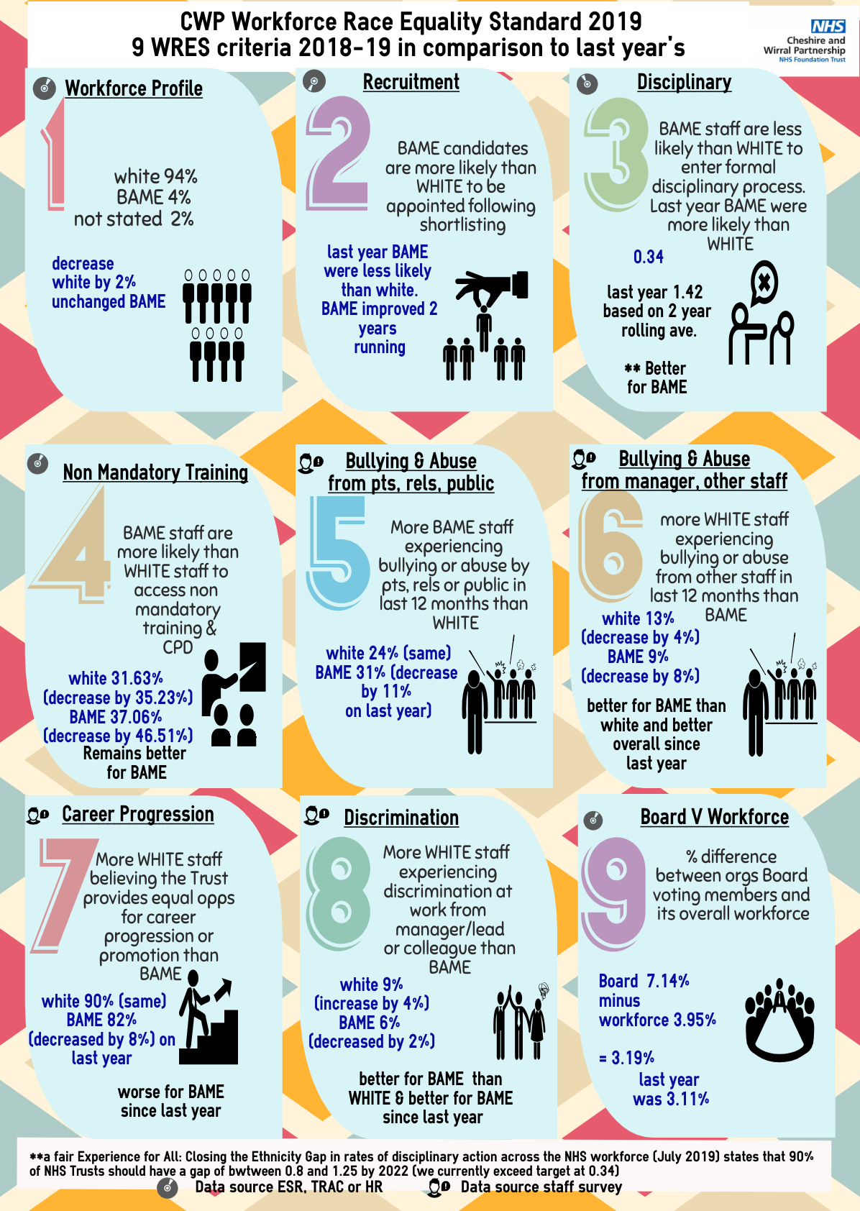

Workforce Race Equality Standard 2018-19

The NHS Workforce Race Equality Standard Indicators

Workforce Indicators
For each of these four workforce indicators, compare the data for White and BME staff
- Percentage of staff in each of the AfC Bands 1-9 and VSM (including executive Board members) compared with the percentage of staff in the overall workforce
Note: Organisations should undertake this calculation separately for nonclinical and for clinical staff
- Relative likelihood of staff being appointed from shortlisting across all posts
- Relative likelihood of staff entering the formal disciplinary process, as measured by entry into a formal disciplinary investigation
Note: This indicator will be based on data from a two year rolling average of the current year and the previous year
- Relative likelihood of staff accessing non-mandatory training and CPD

National NHS Staff Survey indicators
For each of the four staff survey indicators, compare the outcomes of the responses for White and BME staff.
- KF 25. Percentage of staff experiencing harassment, bullying or abuse from patients, relatives or the public in last 12 months
- KF 26. Percentage of staff experiencing harassment, bullying or abuse from staff in last 12 months
- KF 21. Percentage believing that trust provides equal opportunities for career progression or promotion
- Q217. In the last 12 months have you personally experienced discrimination at work from any of the following? b) Manager/team leader or other colleagues

Board representation indicator
For this indicator, compare the difference for White and BME staff
- Percentage difference between the organisations’ Board voting membership and its overall workforce
Note: Only voting members of the Board should be included when considering this indicator

Indicator 1 - Percentage of staff in each of the AfC Bands 1-9 and VSM (including executive Board members) compared with the percentage of staff in the overall workforce
Clinical or non-clinical |  | BME | White | Not stated
Clinical | Band 1 | 0.0% | 0.0% | 0.0%
 | Band 2 | 0.0% | 100.0% | 0.0%
 | Band 3 | 3.0% | 95.6% | 1.4%
 | Band 4 | 3.3% | 95.6% | 1.1%
 | Band 5 | 2.2% | 96.9% | 0.9%
 | Band 6 | 2.1% | 95.7% | 2.2%
 | Band 7 | 4.2% | 91.5% | 4.2%
 | Band 8a | 1.0% | 97.1% | 2.0%
 | Band 8b | 16.7% | 83.3% | 0.0%
 | Band 8c | 0.0% | 90.0% | 10.0%
 | Band 8d | 0.0% | 100.0% | 0.0%
 | Other / Local Pay | 2.3% | 92.4% | 5.3%
 | VSM | 0.0% | 100.0% | 0.0%
 | Medical and Dental | 46.7% | 52.3% | 0.9%
 | of which consultants | 47.6% | 51.2% | 1.2%
 | of which Senior medical manager | 50.0% | 50.0% | 0.0%
 | of which non cons career grades | 42.9% | 57.1% | 0.0%
 | of which trainee grades | 46.2% | 53.8% | 0.0%
 | of which others | 0.0% | 100.0% | 0.0%
Clinical Total |  | 4.6% | 93.2% | 2.2%
Non clinical | Band 1 | 3.2% | 94.6% | 2.2%
 | Band 2 | 3.3% | 96.2% | 0.5%
 | Band 3 | 2.3% | 97.3% | 0.3%
 | Band 4 | 2.9% | 94.9% | 2.2%
 | Band 5 | 1.7% | 96.6% | 1.7%
 | Band 6 | 1.4% | 95.7% | 2.9%
 | Band 7 | 0.0% | 97.6% | 2.4%
 | Band 8a | 8.7% | 87.0% | 4.3%
 | Band 8b | 0.0% | 96.7% | 3.3%
 | Band 8c | 0.0% | 100.0% | 0.0%
 | Band 8d | 0.0% | 0.0% | 0.0%
 | Other / Local Pay | 0.0% | 88.9% | 11.1%
 | VSM | 0.0% | 100.0% | 0.0%
Non clinical Total |  | 2.5% | 96.1% | 1.4%
Grand Total |  | 4.0% | 94.0% | 2.0%

Indicator 2 - Relative likelihood of staff being appointed from shortlisting across all posts

Current Year 2018-19
 | Shortlisted | Appointed | Relative Likelihood of Shortlisted/Appointed
White | 4544 | 295 | 6.49%
BME | 378 | 26 | 6.88%
Not Stated | 150 | 42 | 28.00%
I do not wish to disclose | 40 | 4 | 10.00%
Relative Likelihood of White staff being appointed from shortlisting compared to BME |  |  | 0.94

Previous Year 2017-18
 | Shortlisted | Appointed | Relative Likelihood of Shortlisted/Appointed
White | 3111 | 433 | 13.92%
BME | 264 | 29 | 10.98%
Not Stated | 43 | 14 | 32.56%
I do not wish to disclose | 8 | 2 | 25.00%
Relative Likelihood of White staff being appointed from shortlisting compared to BME |  |  | 1.27

The relative likelihood for the current year 2018-19 indicates that BME staff are MORE likely to be appointed when compared to white staff. This is in contrast to the previous year 2017-18 where BME staff were LESS likely to be appointed when compared to white staff

Indicator 3 - Relative likelihood of staff entering the formal disciplinary process, as measured by entry into a formal disciplinary investigation
Note: This indicator is based on data from a two year rolling average of the current year and the previous year
Current year’s average April 2017 to March 2019
Average over 2 years | Entering Formal Disc Process | Headcount | Relative Likelihood of staff entering the Disciplinary Process
White | 70 | 3367 | 2.08%
BME | 1 | 143 | 0.69%
Not Stated | 0 | 106 | 0.00%
Relative Likelihood of BME staff entering the formal Disciplinary process compared to White staff. |  |  | 0.34

Previous year’s average April 2016 to March 2018
Average over 2 years | Entering Formal Disc Process | Headcount | Relative Likelihood of staff entering the Disciplinary Process
White | 82 | 3258 | 2.52%
BME | 5 | 140 | 3.57%
Not Stated | 0 | 77 | 0.00%
Relative Likelihood of BME staff entering the formal Disciplinary process compared to White staff. |  |  | 1.42

The relative likelihood of the current year’s average for April 2017 to March 2019 indicates that BME staff are LESS likely to enter the formal disciplinary process when compared to white staff. This is in contrast to the previous year’s April 2016 to March 2018 where BME staff were MORE likely to enter the formal disciplinary process when compared to white staff

Indicator 4 - Relative likelihood of staff accessing non-mandatory training and CPD

Current Year 2018-19
 | Accessing non-mand / CPD training | Headcount | Relative Likelihood of staff accessing non-mand / CPD training
White | 1065 | 3367 | 31.63%
BME | 53 | 143 | 37.06%
Not Stated | 26 | 106 | 24.52%
Relative Likelihood of White staff accessing non-mand / CPD training. |  |  | 0.85

Previous Year 2017-18
 | Accessing non-mand / CPD training | Headcount | Relative Likelihood of staff accessing non-mand / CPD training
White | 2146 | 3258 | 65.86%
BME | 117 | 140 | 83.57%
Not Stated | 42 | 77 | 54.54%
Relative Likelihood of White staff accessing non-mand / CPD training. |  |  | 0.79

The relative likelihood for the current year 2018-19 indicates that BME staff are MORE likely to access non-mandatory training when compared to white staff. This is in keeping to the previous year 2017-18 where BME staff were also MORE likely to access non-mandatory training when compared to white staff.

National NHS Staff Survey indicators

Indicator 5 - KF 25. Percentage of staff experiencing harassment, bullying or abuse from patients, relatives or the public in last 12 months
 | 2018 Survey | 2017 Survey | 2016 Survey
White | 24% | 24% | 27%
BME | 31% | 42% | 40%
The results from the latest staff survey indicates that a larger proportion of BME staff have experienced harassment, bullying or abuse from patients, relatives or the public when compared to white staff. This is also the case for the previous 2 years of staff survey results but the percentage is reducing

Indicator 6 - KF 26. Percentage of staff experiencing harassment, bullying or abuse from staff in last 12 months
 | 2018 Survey | 2017 Survey | 2016 Survey
White | 13% | 17% | 16%
BME | 9% | 17% | 15%
The results from the latest staff survey indicates a smaller proportion of BME staff have experienced harassment, bullying or abuse from staff when compared to white staff. This is also the case for the previous 2 years of staff survey results.

Indicator 7 - KF 21. Percentage believing that trust provides equal opportunities for career progression or promotion
 | 2018 Survey | 2017 Survey | 2016 Survey
White | 90% | 90% | 91%
BME | 82% | 90% | 97%
The results from the latest staff survey indicates that fewer BME staff believe the trust provides equal opportunities for career progression or promotion when compared to white staff. For the previous staff survey in 2017 the figures for both BME and white were the same and in 2016.
The proportion of BME staff that believe the trust provides equal opportunities for career progression has reduced from 97% in 2016 to 82% in 2018.

Indicator 8 - Q217. In the last 12 months, have you personally experienced discrimination at work from any of the following? b) Manager/team leader or other colleagues
 | 2018 Survey | 2017 Survey | 2016 Survey
White | 9% | 5% | 4%
BME | 6% | 8% | 3%
The results from the latest staff survey indicates that fewer BME staff have experience discrimination from their manager when compared to white staff.

Indicator 9 - Percentage difference between the organisations’ Board voting membership and its overall workforce

Current Year 2018-19
 | Board Member |  | Overall Workforce |  | Percentage difference between the organisation board voting membership and its overall workforce
White | 12 | 85.71% | 3367 | 93.11% | -7.40%
BME | 1 | 7.14% | 143 | 3.95% | 3.19%
Not Stated | 1 | 7.14% | 106 | 2.93% | 4.21%
As at March 2019, the Trust’s Board is made up of 7.14% of BME staff compared with 3.95% of the overall trust. A difference of 3.19%
Previous Year 2017-18
 | Board Member |  | Overall Workforce |  | Percentage difference between the organisation board voting membership and its overall workforce
White | 12 | 85.71% | 3258 | 93.76% | -8.04%
BME | 1 | 7.14% | 140 | 4.03% | 3.11%
Not Stated | 1 | 7.14% | 77 | 2.22% | 4.93%

As at March 2018, the Trust’s Board was made up of 7.14% of BME staff compared with 4.03% of the overall trust. A difference of 3.11%

