Gender Pay Gap Report 2020

Foreword
From 6 April 2017 employers in Great Britain with more than 250 staff are required to publish their gender pay gap information annually, using six different measures, covering pay and bonuses. This is the second report for Cheshire and Wirral Partnership NHS Foundation Trust (CWP) and provides a snapshot of pay data on 31st March 2020, which is also published on the Gender Pay Gap Reporting pages of the Gov.uk website. The purpose of the reporting is to increase awareness, improve pay transparency and to encourage closing the gap.

What is the Gender Pay Gap?
The gender pay gap is a measure of the difference between men’s and women’s average earnings across an organisation, regardless of the nature of their work and it is expressed as a percentage of men’s earnings.
It is important to distinguish between the gender pay gap and equal pay. Equal pay concerns differences between the actual pay of male and female employees doing equal work, or work of equal value. An organisation may be an equal pay employer, paying male and female staff equally for doing equal work, and it may still have a gender pay gap. CWP employs staff across a range of roles and adheres to the appropriate national NHS Medical and Dental Pay and Conditions and the national NHS job evaluation framework within Agenda for Change. All pay scales provide a process for paying employees equally regardless of gender for the same or equivalent work.

How do we calculate the Gender Pay Gap?
The snapshot date for this report being 31st March 2020 for ordinary pay and a whole 12 months period from 1st April 2019 to 31st March 2020 for bonus pay. For gender pay gap reporting, employees are those employed under a contract of employment to do work. This includes those under Agenda for Change terms and conditions, medical staff and very senior managers (VSM), those employees held on TUPE terms and any Bank Staff who received pay at 31st March 2020. The requirement is to publish six key measures of the gender pay gap:
Mean gender pay gap
The difference between the mean hourly rate of pay of relevant full-pay male employees and that of full-time female employees. This measure captures where men and women sit in the earnings distribution and is the average of all the numbers in the dataset, that is, you have to add up all the numbers and then divide the result by how many numbers you are dealing with.
Median gender pay gap
The difference between the median hourly rate of pay of relevant full-pay male employees and that of full-time female employees. The median measure is used because it isn’t affected by extreme values and is the numerical value that splits the top 50% of the figures from the bottom 50%.
Mean bonus gap
The difference between the mean bonus pay paid to relevant male employees and that paid to female employees.
Median bonus gap
The difference between the median bonus pay paid to relevant male employees and that paid to female employees.
Bonus proportions
The proportions of male and female relevant employees who were paid bonus pay during the 12-month period compared to those who did not receive a bonus.
Quartile pay bands
The proportions of male and female relevant full-pay employees in the lower, lower middle, upper middle and upper quartile pay bands. Effectively we split the workforce into 4 equal quarters based on the average hourly rate of pay.

What is our Gender Pay Gap?

Our Current Staff in Post
Overall as an organisation, we employ more women than men as is seen across many NHS Organisations. We employed 4008 ‘relevant employees’ and 3866 ‘full-pay relevant employees’ as at 31st March 2020, this figure includes 296 bank-only workers were paid in March 2020 and therefore have been used as part of the calculation of our gender pay gap information. 3072 (79%) were female and 794 (21%) were male.

Ordinary Pay
Our mean gender pay gap for average hourly pay is 18.85%. This is higher than the national public sector average of 15.8% as identified by the Office for National Statistics Annual Survey of Hours and Earnings published 7th December 2020. When comparing our median figure, we have a 1.50% pay gap compared to the national public sector average of 14.5%.
 | Female | Male | Difference | Pay Gap % | National Public Sector Pay Gap %
Mean Hourly Rate | £17.0463 | £21.0050 | £3.9587 | 18.85% | 15.80%
Median Hourly Rate | £15.5472 | £15.7835 | £0.2363 | 1.50% | 14.50%

CWP Trust
When reporting our pay gap for all staff employed at the snapshot date our mean hourly pay gap is 18.85% and the median pay gap is 1.50%

Highlighting Staff on Agenda for Change Terms and Conditions
When reporting solely on staff that are on Agenda for Change terms and conditions our mean hourly pay gap is 1.53% and the median -2.05%

Highlighting Staff on Executive Team
When reporting solely on staff that are on Executive terms and conditions our mean hourly pay gap is
-17.20% and the median -25.41%

Highlighting Staff on Medical Terms and Conditions
When reporting solely on staff that are on Medical terms and conditions our mean hourly pay gap is 11.70% and the median 9.39%

Highlighting Staff on Local Terms and Conditions
When reporting solely on staff that are on Local terms and conditions our mean hourly pay gap is 12.79% and the median 21.56%

Further detail regarding the gender pay gap across pay bands, staff groups and comparing year 16/17 to 19/20 is provided in the appendices.

Bonus Pay
Bonus pay includes Clinical Excellence Awards, Recognition of Service Awards and Discretionary Points paid between 1 April 2019 and 31 March 2020 for all relevant staff. During the year, 146 staff received these payments with the median amount for women being £100.00 and for men £3013.86 with a pay gap of 96.7%. The mean average amount was £1729.28 for women and £57094.28 for men with a pay gap of 75.6%
 |  |  |  |  | % of trust staff by gender who received bonus
 | Female | Male | Difference | Pay Gap | % Female | % Male
Average Bonus Pay Value | £1729.28 | £7094.28 | £5365.00 | 75.6% | 3.13%  100 out of 4008 | 5.67%  46 out of 812
Median Bonus Pay Value | £100.00 | £3013.86 | £2913.87 | 96.7%
Highlighting on Recognition of Service Awards
107 staff received recognition of service award vouchers where the median for both men and women is £100, with the pay gap as 0.00% for these awards in isolation. The mean average amount was £125.88 for women and £125.27 for men with a pay gap of -0.49%.
Highlighting on Clinical Excellence and Discretioinal Points Awards
42 staff received Clinical Excellence Awards and Discretioinary points. When looking at these payments alone, the median amount for women being £5692 and for men was £9010 with a pay gap of 36.83%. The mean average amount is £10,139 for women and £12,443 for men with a pay gap of 18.52%.

Gender Pay Gap Metrics Summary
Gender Pay Gap | Bonus Pay Gap | Proportion of Employees Who Received Bonus
18.50%  Mean Hourly Rate | 75.60%  Mean Bonus Payment | 3.13%  Of trust Female staff
1.50%  Median Hourly Rate | 96.70%  Median Bonus Payment | 5.67%  Of trust Male staff

Proportion of employees in quartile bands
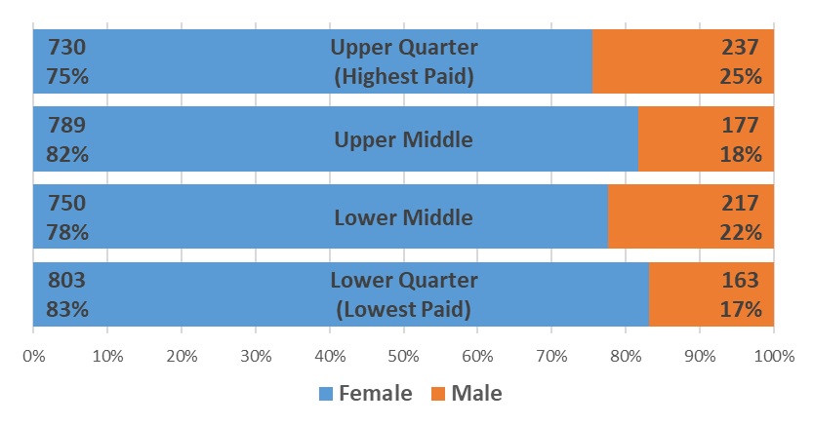
In CWP, women occupy 75% of the highest paid jobs and 83% of the lowest paid jobs.

How our pay gap has changed
Mean Hourly Rate Pay Gap % Year on Year  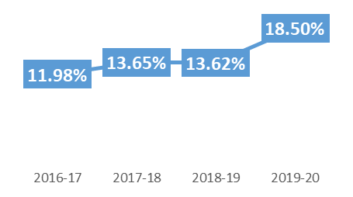 | Median Hourly Rate Pay Gap % Year on Year  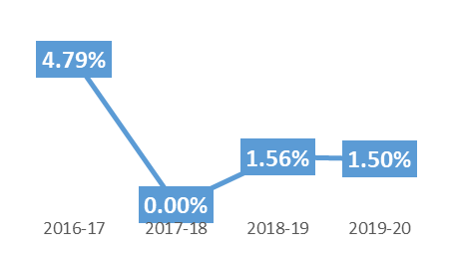
Mean Bonus Payment Pay Gap % Year on Year  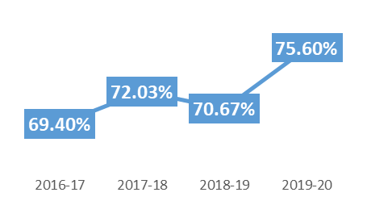 | Median Bonus Payment Pay Gap % Year on Year  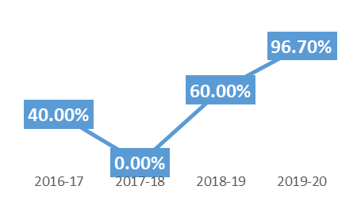
Due to the global pandemic, this report was produced much later that it would be ordinarily, and it was more prudent to move to producing the 2020-21 report early, to give the Trust the accurate picture on which to reflect on its gender pay gap journey and develop an appropriate action plan. However, we have identified in producing this year’s report an incorrect calculation that was made when calculating the hourly pay rate of GPs in our Out of Hours service, which results in the spike for this year of 18.50% mean ordinary pay gap.

Our Next Steps to tackling our Gender Pay Gap
Please see the latest 2020-21 Gender Pay Gap report on our website: https://www.cwp.nhs.uk/about-us/our-vision-and-values/equality-and-diversity/

Appendix 1 – Average Hourly Rate by Groups
